A Complete Project in Fabric
Here we are going to get dimensional table and fact table data separately and stored in lakehouse and do some transformation like dataflow stored in datawarehouse and create pipeline get the complete dataset and perform reporting in powerbi.

Create a new workspace to perfrom the fabric project
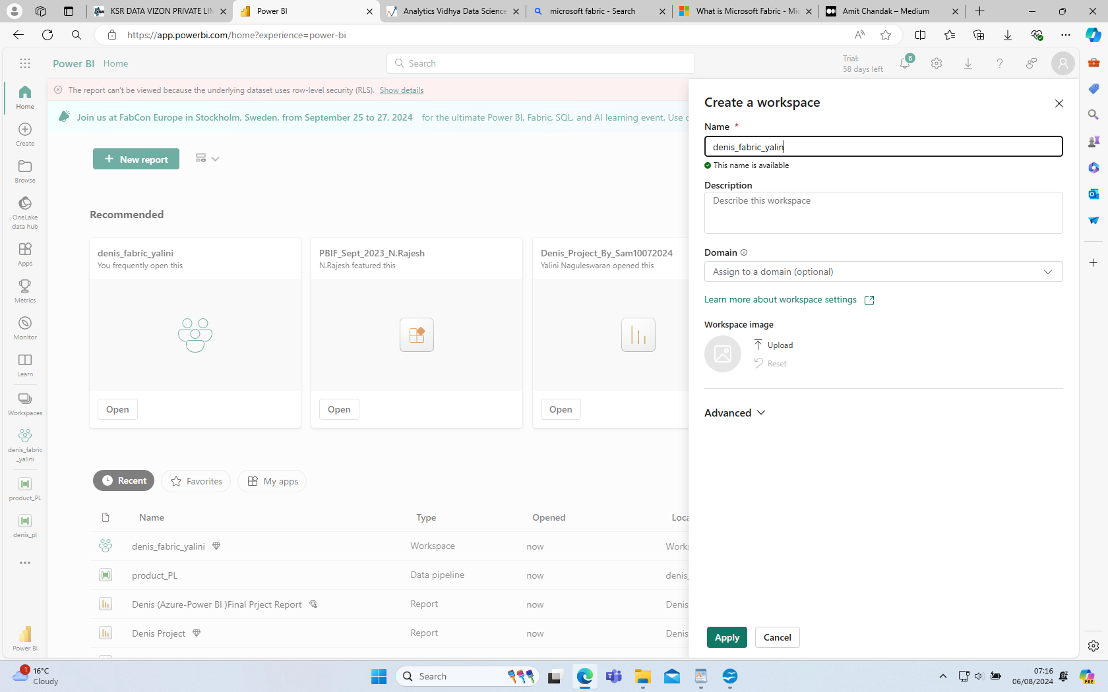

In the wokspace go and create a lakehouse to store all our files

Lakehouse is created start upload all files and folders.

Next is to get the data from lakehouse and start transform the each files

here is the category data and we dont need transformation simply save the file and put it into the destination, choose destination as datawarehouse and publish

Similarly choose other file as product data do some transformation like first row as header and remove the duplicates put into the warehouse and publish.

In salesrep files remove the id and make it as numbers and publish

Finally we did cleaning for all the files and folders and all are stored in the workspace, below is the image of all cleaned files and lakehouse present in the workspace.

Next step is to create the pipeline for all the dataflows , create a pipeline give name as category_PL

choose the dataflow activity, in the settings choose dataflow as category_DF

Next, choose subactegory dataflow , similarly choose create pipeline for all the files and folders.

finally create a denis dataflow in which final transformation of all files will be done, like join 2 tables using same column in the tables.

Below picture is the final transformation of all the files

Create a denis_PL to run the output , first create a 6 invoke pipeline choose files for each pipeline connect all dimensional table to sales table and connect to denis_DF activity

Finally run the pipeline

output is display in the warehouse tables in the denis_tb

From here we can use this table to create a report in powerBI

